Designed with the user in mind
Pandrol’s holistic approach to safety is reflected in our ergonomic equipment design.
When we talk about safety on railways, it’s natural to think of the extreme dangers that people sometimes face when working on track with moving vehicles. However, while these hazards are always at the forefront of our minds, at Pandrol we also focus on the long-term safety of track teams by seeking to improve day-to-day working environments through effective use of ergonomics.
UNPACKING ERGONOMICS
Ergonomics is the scientific study of people and their working conditions. Our Pandrol ergonomic specialists use their knowledge and understanding to ensure equipment and tools are designed to increase
productivity and efficiency while reducing discomfort and fatigue. The result? A safer workplace and reduced costs.
In the office, this is likely to mean adjustable workstations and computers, ergonomic chairs and a footrest under the desk. On track, it might be lighter equipment that reduces time spent kneeling, automated processes, or battery-operated products that reduce noise and fumes.
ERGONOMICS IN PRACTICE
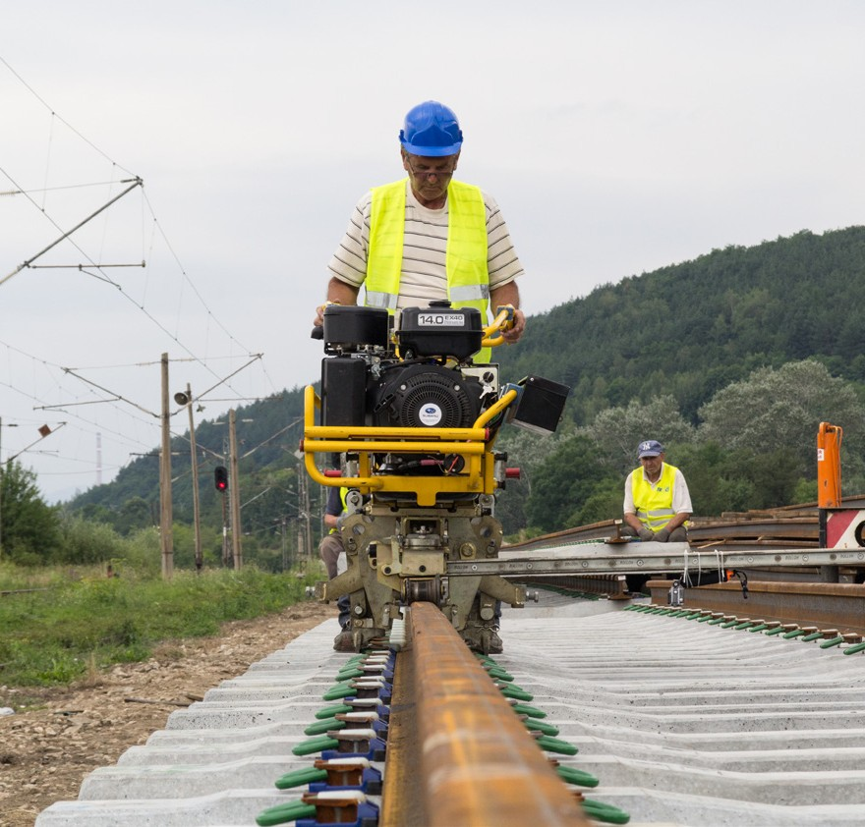
Often, speed and efficiency go hand in hand with designing products and processes that reduce fatigue and improve the working environment. A good example of this in practice is the Vortok Stressing Roller (VSR), which is used when rail stressing and changing sleeper pads. The VSR is attached to the rail fastening and
lifts the unclipped rail from the sleeper by means of a rotating lift arm and bearing. To reduce friction,
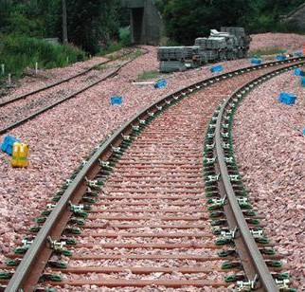
ball races are used instead of plain rollers, and are in contact with the underside of the rail head rather than the foot or web of the rail. Once lifted, the rail can be moved with very low friction and the resultant stress distribution is optimised.
By enabling rails to be lifted and moved with ease in this way, the VSR offers:
- higher productivity
- a significant reduction in labour and operator effort
- time savings of more than two hours on a standard 900m stressing operation.

TECHNOLOGY-ENHANCED ERGONOMICS
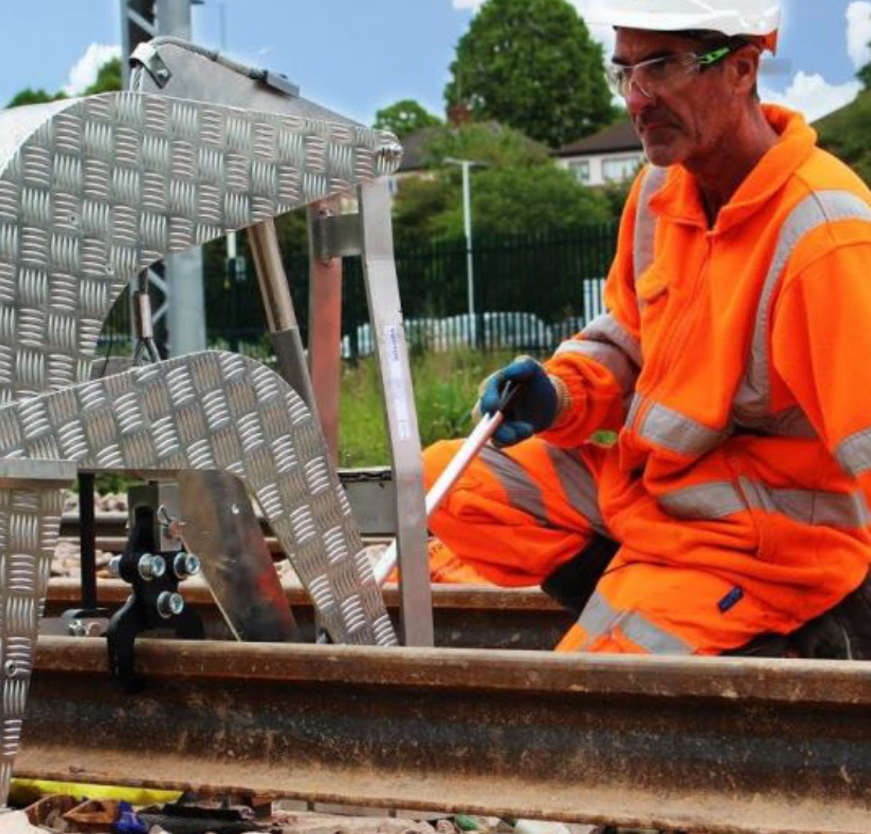
Technology is often used to further enhance ergonomic solutions. In the case of the Vortok Stressing Roller, the precision of the rail stressing process is improved by the use of VERSE – a lightweight, accurate, low-cost monitoring system that checks a rail is at the correct stress-free temperature. This allows operators to predict where track is vulnerable to stress-free temperature change and plan cost-effective re-stressing
programmes, reducing the risk of buckling and fracturing and achieving new track quality acceptance.
With VERSE, the rail’s stress-free temperature is determined immediately, trackside, using a handheld computer. Readings are exported, with files downloadable to databases like Excel and Access for integration with other track data. Where necessary,
on-the-spot maintenance and safety decisions can be made without knowledge of any residual stress history of the rail. With each measurement taking just 20 to 30 minutes (depending on the rail fastening), less time is needed, fewer people are on track, and more accurate results are achieved.
A win-win, stress-free solution from every perspective!
