PANDROL ADVANCED:
Changing the game for welding
Our new Pandrol Advanced welding process harnesses innovation every step of the way.
As a standard-setting rail technology company, Pandrol is constantly driving industry innovations – leading the way on everything from environmental responsibility to technical best practice across the board.
PRE-ASSEMBLY IN PRACTICE
As part of its enduring commitment to sustainability, Pandrol is taking steps towards improving its world-leading welding process. Having realised that the process itself had undergone minimal change since initial implementation, Pandrol spent time analysing its efficiency in terms of time, safety, accuracy and environmental impact. Armed with these insights, the organisation was equipped to create Pandrol Advanced, a brand-new process for better, more effective welding.
Pandrol Advanced harnesses innovation at every step of the welding process to save time and improve safety, ergonomics and weld quality.

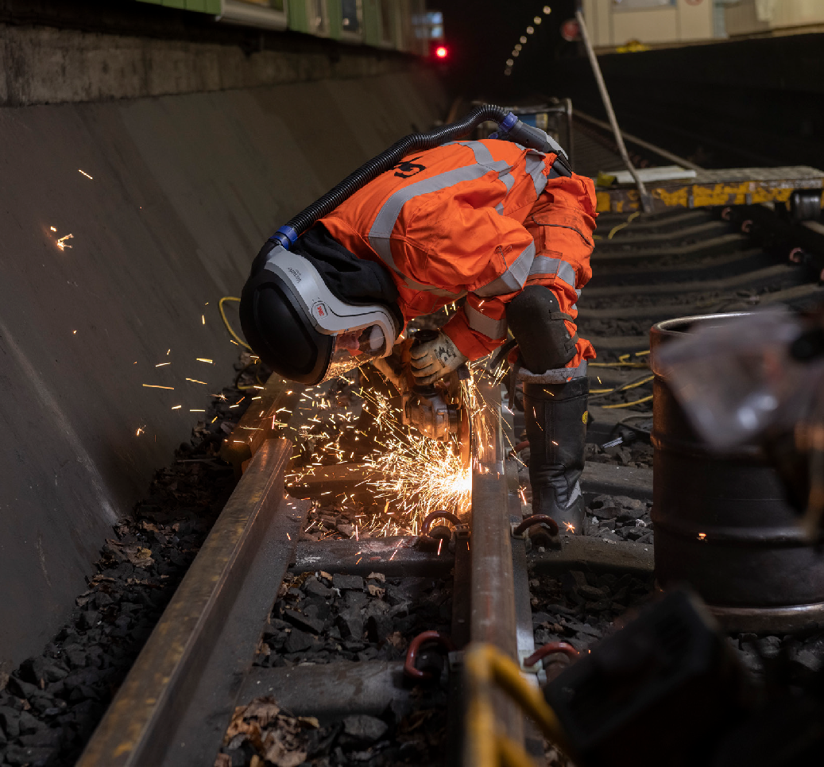

INNOVATION 1
01
AUTOSEAL MOULD
Aluminothermic welding traditionally involves luting – sealing moulds to rail ends with paste or sand to avoid metal leaks. But with Pandrol Advanced, the luting process is replaced by AutoSeal, he world’s first self-sealing mould. AutoSeal comes with a built-in insulation joint that expands during pre-heating to create a tight seal when fitted onto the rail.
AutoSeal offers a number of key benefits that serve to make the entire welding process more efficient. Firstly, it reduces the time spent on each weld by a minimum of five minutes, thanks to its ability to automatically seal the mould and eliminate the need for luting. This moulding system also makes sealing more reliable, lowers the defect rate by evacuating moisture during preheat, and puts welders’ health first by reducing the time they need to spend kneeling. AutoSeal also means less plastic waste, lower energy requirements and a reduction in overall environmental impact
– making it a highly efficient alternative to traditional methods of welding.
INNOVATION 2
HIGH FLOW PREHEATER
Fully optimised for use with Pandrol’s High Flow Preheater (HFP) – the universal preheating system brought in to replace all current equipment – the Advanced process raises the parent steel’s temperature prior to welding. As opposed to the mix of oxygen and propane used by most existing preheating systems, the HFP uses pure propane, eliminating the cost of oxygen and improving the welders’ onsite experience thanks to the equipment’s lower weight and smaller canister. And with the ignition, timing and stop all fully automated, there’s no need for lengthy manual interference or flame adjustment.
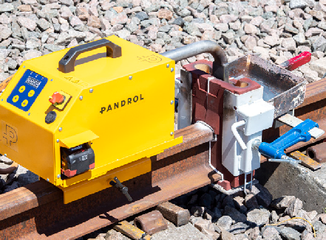
The battery-powered High Flow Preheater (HFP) in use
As Frédéric Delcroix, Pandrol’s Welding Technical Director, explains: “Our High Flow Preheater’s built-in timer increases accuracy – improving quality and reducing the defect rate of welds due to preheating, which can be a real problem for rail operators. By providing a uniform preheat between the head and bottom of the rail, the High Flow Preheater reduces stress in the weld. We’ve also made it easier to operate; there’s no need to adjust the torch height, which saves time, and as the system is fully automated, less training is required. It is straightforward for new welders to learn to operate, and offers the added reassurance that comes from knowing the preheat has been even.”
INNOVATION 3
CJ1 ONE SHOT-CRUICIBLE
The Pandrol Advanced process also selects the smaller, CJ1 one-shot crucible rather than the larger CJ2 version, making it suitable for all standard gap and head wash repair welds, which accounted for 98.5% of all welds cast by Pandrol in the UK in 2019. Thanks to pre-installation conducted by a Startwel® electronic ignition system, the CJ1 design makes igniting the portion within the crucible safer and easier. Using it as part of the Pandrol Advanced process also reduces waste, cost and requirements for packaging and transportation due to its lighter weight and non-explosive classification.
31
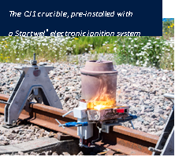
INNOVATION 4
PANDROL CONNECT APP

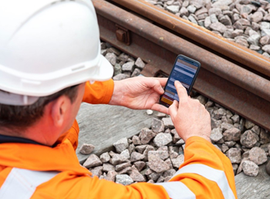
With the Pandrol Connect welding app giving welders the ability to manage the entire Advanced process digitally from their device, the method is more effective and environmentally efficient than ever.
This technology means that instead of recording data manually, welders can input information straight into the app before, during and after welding, with reviewing carried out by welding controllers and monitored from the office.
The Pandrol Advanced process is paving the way for innovations across the board in condition and maintenance. With fit-for-purpose practices such as the AutoSeal mould, HFP and CJ1 crucible used throughout, the process has redefined what’s possible when it comes to environmental responsibility and efficiency in the welding process. From its position at the cutting edge of welding technology, the future looks bright for Pandrol – and for all those who follow our example.

