Pre-assembly and our promise
John Porrill, Technical Director and Head of the Fastening Systems Product Line, explores how pre-assembled fastenings align with the Pandrol Promise.
The practice of pre-assembly is becoming increasingly common across a range of sectors, and its benefits are widely recognised – from eco-friendliness, safety and quality, to savings in cost and time. As this suggests, pre-assembly is a natural fit with our Pandrol Promise and we are looking to maximise it increasingly in our new and existing products as a great way of adding value to the client.
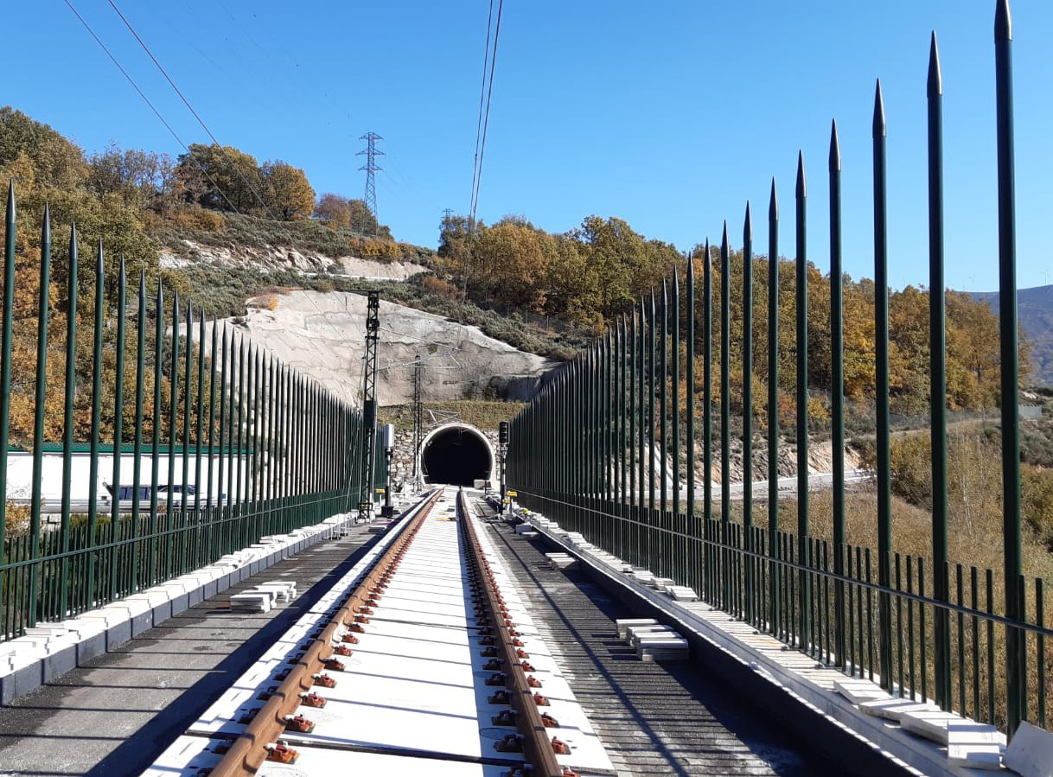

PRE-ASSEMBLY IN PRACTICE
The Fastclip Baseplate (FCB) is a good example of how Pandrol is putting this into practice. The FCB is a fastening system for non-ballasted track applications that
enables a range of both vertical and lateral adjustments to be made quickly and easily, with minimal additional components.
It can be used with all typical track construction methods and configured for various track stiffness and rail clamping force requirements.
The FCB already combines safety, durability and the latest technology,
and provides excellent track references. Offering the option for pre-assembly brings another dimension to its benefits.
When pre-assembled, the FCB is supplied as a captive unit with the clips in the parked position. On pre-cast concrete elements, the unit can be positioned and tightened down into precise alignment.
When used with top-down wet pour track construction methods, the unit is hung from the rails prior to concrete being poured to the required level.
9
WHAT ARE THE BENEFITS?
Contractors and the railway benefit in a number of ways from opting for pre-assembled baseplates.
- The product comes complete and correctly assembled – the risk inherent in putting parts together from a loose bag of components is eliminated.
- Installation is quicker and safer – the fiddle factor is taken out!
- Pre-assembled units lend themselves well to mechanisation, robotics and automation. For example, robots can apply pre-assembled FCBs to sleepers or slab track 24/7, with a much higher level of consistent accuracy and reproducibility than is possible with manual application.
- As this suggests, accuracy is enhanced by the use of pre-assembled fastenings, particularly when combined with automation. This is particularly important in applications like high speed, where the degree of accuracy needed in placement is considerably more sensitive than in heavy haul or even a standard mixed freight track.
- If a slab unit is damaged in track, it can be replaced quickly and safely by an identical unit. The new FCB modules can be fitted quickly and with the same pattern of accuracy as the original, using data stored on an RFID tag located on the original slab unit.
- Importantly from an environmental perspective, it is still possible to replace individual components within the pre-assembled unit. For example, pads and insulators might need to be replaced during the lifetime of a rail. Pre-assembly of sub-components can support this – a replacement clip comes with a toe insulator already fitted, for example, saving time spent on maintenance processes.
Considering these factors, our use of pre-assembly will surely grow as we focus on keeping our Pandrol Promise to customers in all we do.

