Signalling equipment made easy
Modern signalling systems and balises require a modern solution. Craig Mulvay, Technical and Commercial Development Manager, explains why.

Balises are a crucial part of the modern railway system. Acting as a kind of central nervous system for the rail network, balises work as beacons or transponders, communicating to give an accurate location of the train for modern signalling systems, such as European Train Control Systems (ETCS) and Communication Based Train Control (CBTC). If fitted incorrectly, operators run the risk of losing the safety-critical data which balises transmit. For a reliable rail network, rapid and efficient installation is key.
Pandrol’s unique position as track experts with additional knowledge of the signalling interface makes us market leaders – not only in providing balise-fitting equipment, but also in creating bespoke solutions for customers’ unique needs. Our design capability saves customers time and significantly reduces the total cost of deploying modern signalling equipment into the track environment.
COST-SAVING INNOVATIONS
Traditional methods of balise-fitting installations are laborious, with ballast needing to be removed from around sleepers or alternatively, sleepers needing to be drilled and anchored directly. These practices can be risky, opening up the possibility of degrading track support or damage to sleepers, which could prove costly later down the line.
The Pandrol (Vortok) Balise Mount Systems (BMS) have revolutionised balise installation. The BMS On Sleeper Beam and BMS Clamp Beam increase efficiency and ultimately reduce costs for customers.
With no power tools needed, installation can be facilitated using simple hand tools. This means that our solutions can be fitted in a single track visit, as opposed to traditional methods where sleepers must be identified, drilled and anchors installed, with additional drying time allowed over the course of multiple site visits. This reduced time for installation and track possession equates to savings in the cost of installation too, by decreasing labour requirements and improving project management flexibility for operators. In addition, Pandrol products have the ability to be part-installed withall the mechanical parts fitted prior to the electronics, if needed.
With our On Sleeper Beam, we estimate on-track time of less than two minutes per beam installation. The beams are as easy to remove as they are to install, without the need for specialist tools or adjustment. This means that infrastructure owners also reap the reward of the quick-fit Pandrol system as the system can be removed and replaced quickly before and after major maintenance works to the track. After installation, should commissioning checks require adjustments to be made, these will be easy to do with the equipment repositioned in a fraction of the usual time.
PERFECTLY POSITIONED FOR ACCURACY
The positioning of balises is vital for reliable data transfer to on-board rolling stock receivers. If the transponder isn’t placed within tolerance, there is a risk the train will fail to read it when passing over the track. That makes reliable balise positioning vital for safe and reliable signalling systems.
Using traditional methods of fitting, users would need to manually position the balise, working out the correct spacers between the balise and the top of the sleeper so that it ends up at the correct height in relation to the head of the rail. This can lead to issues with balises being installed incorrectly. If the positioning ends up being too high, too low or off-centre, this will impact the reliability of the railway or cause delays with the project overall.
But with our balise-fitting equipment, the product arrives to site pre-positioned by the Pandrol design team, so that no additional positioning is required on site.
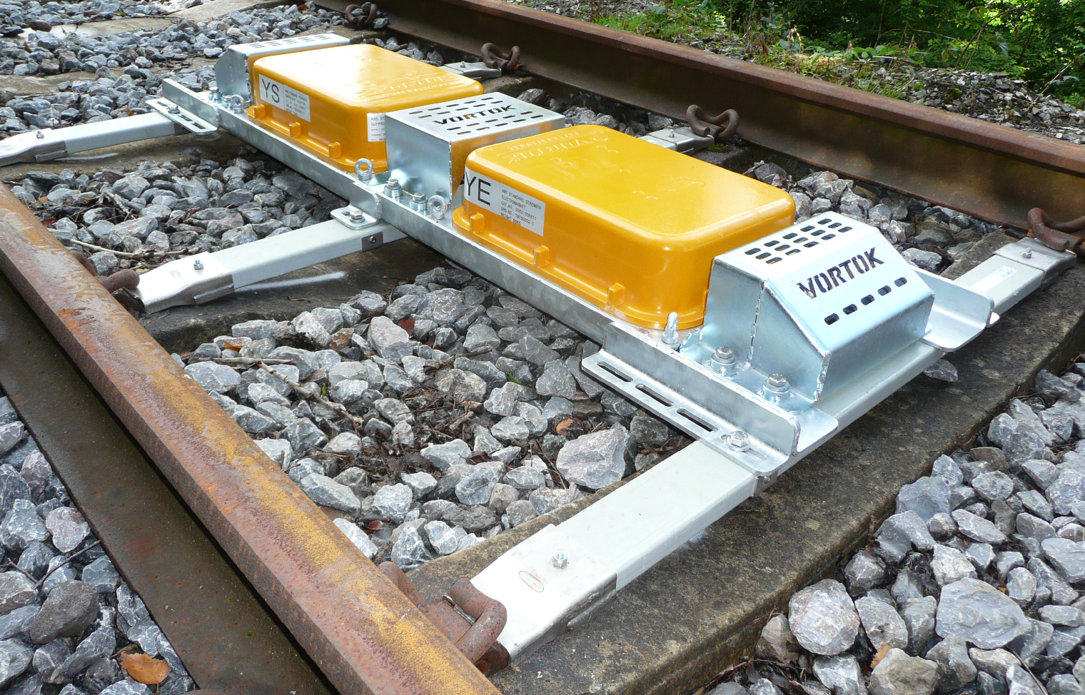
This removes the risk of human error and significantly reduces the risk of read errors between balise and receiver. Our simple solution has created a more efficient and simple process.

PRODUCTS IN FOCUS
The Pandrol (Vortok) BMS have been used to install a wide range of signalling equipment, including balises, transponders, beacons, norming points and RFID tags. Since 2001, Pandrol has sold over 250,000 Clamp and On Sleeper Beams.
The On Sleeper Beams use the existing rail fastening as an attachment point and are capable of interfacing with all major fastening systems, such as Pandrol’s own e-Clip, Fastclip and NABLA, as well as Schwihag, Vossloh, K-type Plates, Delkor and direct to timber sleepers.
On Fastclip and e-clip systems, simple hand tools can be utilised to extract the clip and put it back in. Using the heel load (the reactionary load) of the clips to hold down the beam, the clips can be removed using the hand tool, the beam placed in position and the clips reinstalled.
Balises can either be positioned over the sleeper to allow open access to the space in case the consolidation of the ballast is required, or they can be placed between the sleepers. For the latter option, Clamp Beams can be secured to track via mechanical clamping to the underside of the running rail foot. These are available in single or double clamp beam formations.
BESPOKE DESIGN SOLUTIONS
Our equipment can be adapted to solve virtually any on-track signalling equipment challenge. So when customers have unique requirements that go above and beyond the standard signalling equipment, we have the ability to develop great solutions to solve their problems.
As part of our product offering, we can create bespoke designs, managing the entire process for customers. We can reduce
the total cost of install by using smart solutions which facilitate the deployment of equipment into track environment in the most efficient way possible.
Pandrol’s track engineering expertise helps signalling customers to analyse and understand the optimum method of installing signalling equipment into their unique track environments. Where most providers are either experts in track or signalling interface, at Pandrol, we have the knowledge and understanding of both.
SYDNEY METRO: A SPECIALIST SOLUTION
One example of our bespoke products created through collaboration with customers for project-specific applications is the Anti-Trip BMS specially developed for Sydney Metro.
Sydney Metro required access through its metro tunnel so that maintenance staff and passengers can walk safely down the centre of the track, for example in an emergency scenario.
To meet these needs, Pandrol designed a product which could assume two roles. The Anti-Trip BMS is a specialist product which installs a balise into the track whilst also forming a walkway route through a tunnel. Our bespoke system utilised the Clamp Beam system to avoid the requirement of drilling into the track, and also met the multiple requirements of the customer.

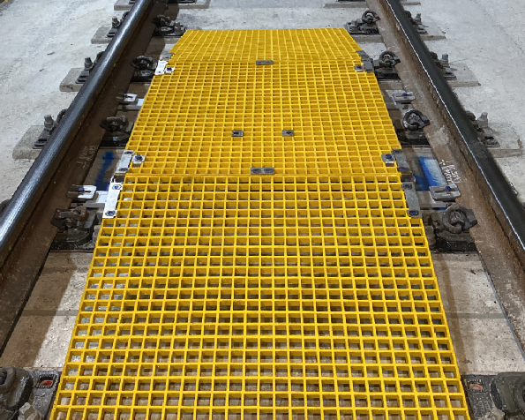

BALISE PROTECTION FOR COLD CLIMATES
In colder climates, the track can suffer from a phenomenon known as ‘ice bombs’ or ‘ice shedding’. When a train accumulates ice on its body, changing pressures when exiting tunnels can cause huge chunks of ice to fall off the train. These large lumps of ice can smash into signalling or other equipment when they land in the track environment, causing severe damage.
In response, we developed equipment to protect the balise even if ice hits it, taking the impact and protecting the balise. Though the technology was quite the engineering challenge, the design we created has been tested to withstand the customer requirement of a 10kg particle travelling at 250km/hr.
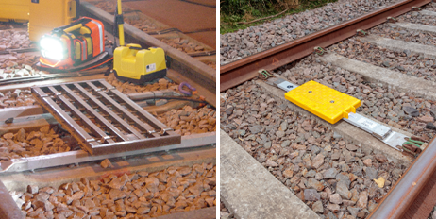
A WORLD OF KNOWLEDGE
Pandrol has a long history in the development of mounting systems, with our extensive experience informing our current offering. Prior to BMS, Pandrol supplied Train Protection & Warning System (TPWS) mounting frames, which used similar materials and construction methodology. The first TPWS units were deployed in 1990, and since then more than a quarter of a million balise mount systems have been sold worldwide.

BALISE PROTECTION FOR COLD CLIMATES
In colder climates, the track can suffer from a phenomenon known as ‘ice bombs’ or ‘ice shedding’. When a train accumulates ice on its body, changing pressures when exiting tunnels can cause huge chunks of ice to fall off the train. These large lumps of ice can smash into signalling or other equipment when they land in the track environment, causing severe damage.
In response, we developed equipment to protect the balise even if ice hits it, taking the impact and protecting the balise. Though the technology was quite the engineering challenge, the design we created has been tested to withstand the customer requirement of a 10kg particle travelling at 250km/hr.
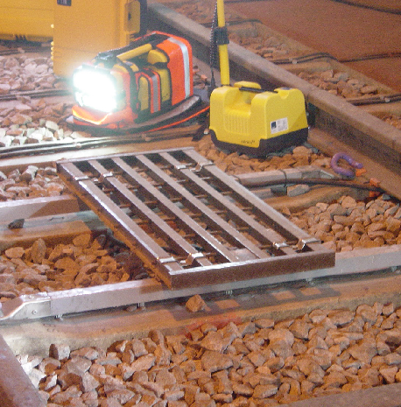
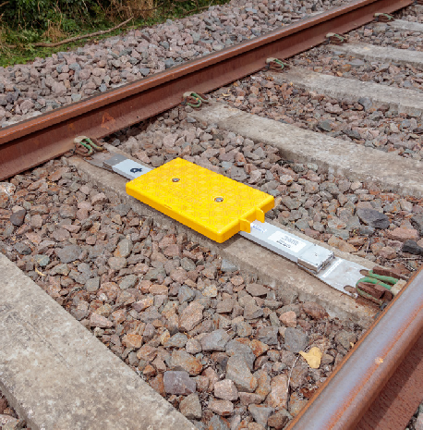
Our pioneering work for TPWS includes the innovation of track fasteners as a fixing point and pultruded fiberglass as a structural material to support the signalling asset. Following this, we launched our first official BMS, the H-Frame, followed by the heavy-duty Automatic Warning System (AWS) Rapid Fit Frame, capable of carrying up to three AWS magnets of over 70kg each.
Today, Pandrol’s established design fundamentals underpin the work we do, with Pandrol BMS supplied to over 20 countries worldwide. Our products certainly stand the test of time, with high-quality innovative solutions that make us the largest player and true market leaders in the signalling equipment space.

