UNDER SLEEPER PADS IN HEAVY HAUL
Under Sleeper Pads are on the up in heavy haul, playing an important role in extending the life of the railway.
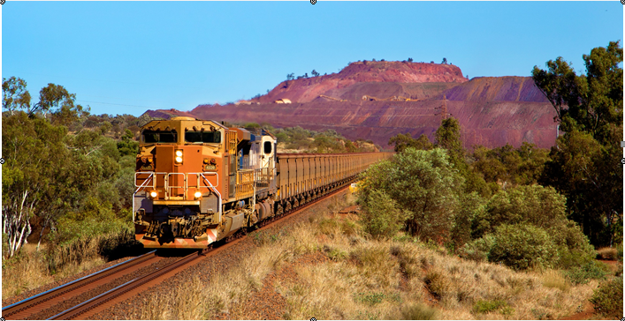
Recent years have seen a rapid growth in the use of Pandrol’s Under Sleeper Pads (USPs) in heavy haul railways. So why are USPs so useful when loads are high?
The main purpose of USPs in heavy haul is track protection. Introducing an elastic element to the base of sleepers improves load distribution over the track and its components, both longitudinally and transversely.
Without USPs, ballast is the first elastic track element to consider. Fasteners and ground are also resilient, whereas the wheel, track, and sleepers are all rigid.
When heavy loads pass over the track, the ballast is compressed and, with a ballast sleeper contact area of between five to eight per cent of the total surface, the compacted ballast gets stiffer.
Under Sleeper Pads introduce an additional elastic element between the ballast and the sleeper. As a result, the contact surface increases to over 30%, improving load distribution, consistency of track stiffness and overall track quality. Different USP specifications are available to provide the ideal elasticity for specific rail infrastructures. Elastic levels need to be controlled to ensure that while the stiffness of the system is decreased, the elasticity doesn’t cause too much track deflection.
LIFELONG BENEFITS
What are the long-term benefits of this?
- Less rail corrugation (especially on curves)
- Reduced frequency of levelling, lining and tamping (by a minimum factor of two)
- Lower maintenance costs Extended life of the
- track superstructure

With such compelling reasons for their use in heavy haul, the future looks bright for Pandrol’s USP solutions.

